Unst Partnership - Chairman’s Report 2019-20
The year began well with the second-hand shop continuing to do good business, our skip scheme popular as ever and a good number of tourists here over the summer. With the advent of CV-19 towards the end of the financial year, our shop closed in March and has only recently re-opened.
Secondhand Shop
The shop traded well in 2019-20 with numbers visiting and overall spend continuing to exceed expectations. In our second year of trading, income from the Shop from April 2019 until March 2020 was £14,164 with 5,227 people through the door, a great success and congratulations to all involved, particularly our Development Officer.
The shop takes in approximately £1000 per month which along with our other activities allows us to be sustainable. We purchased our own PAT tester to check electrical goods.
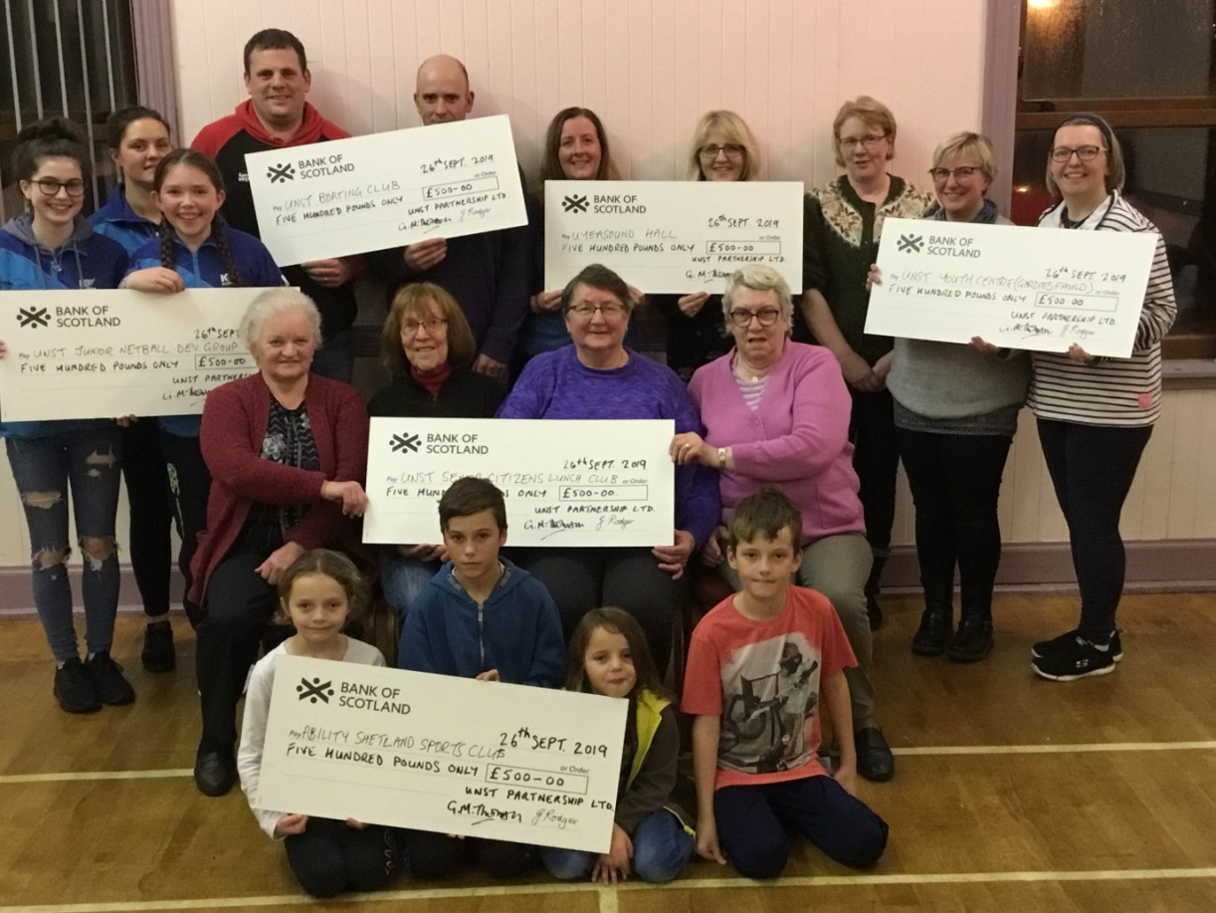
We held a Participatory Budget event last October/September and gave out £3000 to local groups (Unst Senior Citizens Group, Gardiesfauld Hostel, Uyeasound Hall, Unst Boating Club, Unst Junior Netball Development Group and Ability Shetland.)

We continue to sell locally made jams, marmalade and chutneys and Traidcraft items. We have also received regular donations of bannocks and plants to sell. Community support continued well, right up until our closure day in March.
In March 2020, we placed our Development Officer on furlough until August, but continued to pay the additional 20% deficit.

Community Skip scheme
The Community Skip scheme continued to be well supported in 2019-20 with six Skip Saturdays taking place and over 50 residents taking out an annual Skip Membership at £45, and around 20 “occasional users” paying £20 a time. It costs over £600 for each Saturday and this would not have been possible without the support of the community. It still makes a loss which we subsidise from our Reserves.
Many thanks to Garriocks who bring our skips; and to the Shetland Amenity Trust who take metal and white goods away. We would also like to acknowledge the work of the local volunteers who have turned out to support the Directors at these events and to Sandisons Unst Ltd. for allowing us to use the Pierhead area for drop-off.
Other Projects

Gordon Thomson continues to write the “Isles Views” Shetland Times column and it has brought in a useful additional income stream. The Tourist Map in 2019 was well received, with 5,000 free copies printed as well as the online version on our website. The “Unst Walkers are Welcome” website is also up and running, with information on walks in Unst and Fetlar. We still have copies of the “Collaster Walk Guide” to give out to those interested.

Other income is obtained through our 6Kw Wind Turbine, trailer hire, photocopying & printing and our three community polytunnels. We have still not resolved the issue of water supply at the polytunnels.

Broadband
The R100 Broadband for Public Buildings scheme was delayed but did eventually get laid in the summer of 2020. The link-up date for public buildings is now Christmas 2020, with the eventual roll out of private links to that network from 2021 onwards. 4G mobile phone reception is now available in some parts of the island.
Shetland Space Centre
The Space Centre project was held up for a time due to the pandemic, with Pre-Planning and online public consultation in May 2020 and further consultation planned in October 2020, when Planning Permission is to be submitted.
Halligarth
Work on the house at Halligarth has more or less been abandoned but the NTS have agreed to pay a contract for grass-cutting in the woods and surrounding area. They have also arranged with a local contractor to repair doors and windows at Roselea, the house north of the woods.
CV-19 Anchor Organisation
As the pandemic worsened in March, UP applied to HIE to become the Community Anchor organisation for Unst, in conjunction with Unst Community Council. We put in a bid for funding Food Orders for those in need (using donations to a Food bank no longer being practical) and for a Community Newsletter to keep residents informed of any changes in Health Centre operations and shop openings, etc. The Fund came to over £7000 and was designed to run from April – August/September 2020. The fund later expanded to include electricity vouchers as well as petrol costs for volunteers delivering NHS prescriptions.
2020-21
In the year ahead,
- we will continue to monitor the CV-19 situation to see if further community funding is required post-furlough
- we are continuing to fund our Development Officer until March 2021. We will then review the position but despite the recent pandemic, trade has started to pick up again and we are optimistic that the post and shop will continue.
- Directors took an important step towards a Recycling Centre in Unst reaching an agreement with Unst Show Committee to purchase land at Hagdale for this building and associated works such as car park, laundry, wood store, compound for scrap items, etc. This Project will form much of our work in the next few years.
- we are always keen to see volunteers wishing to assist at our Shop or on our Skip Days.

As usual, our thanks to all our Directors this year and to the staff at Bon Accord Accountancy for assisting with our payroll and compiling our annual accounts.

Gordon Thomson, Chairman and Directors 2019-20

